Currently, Big Mountain Resort has some of the highest quantities of amenities offered compared to other resorts in the same market share.

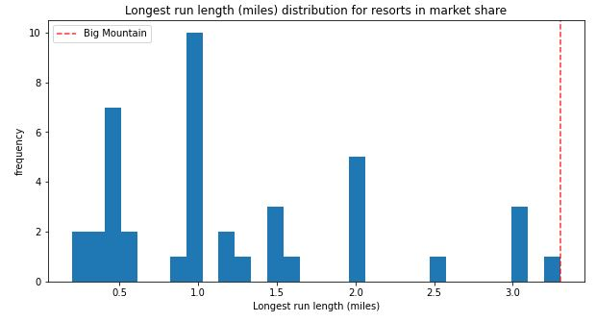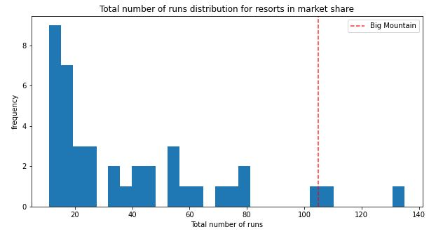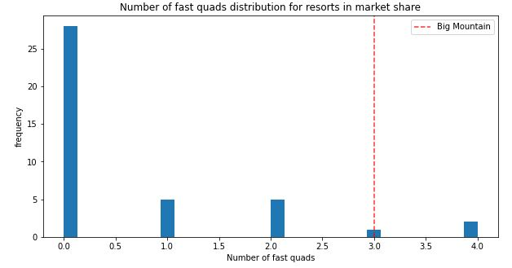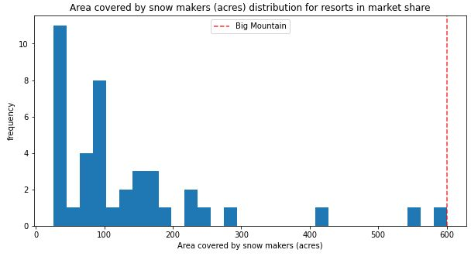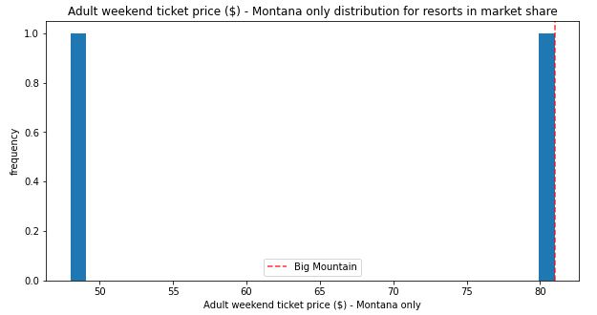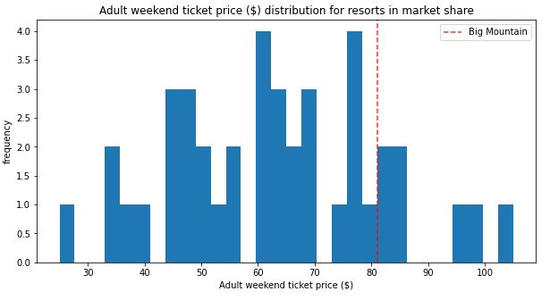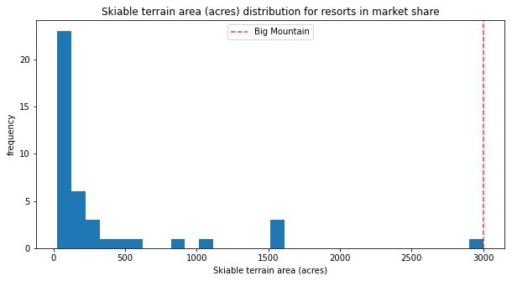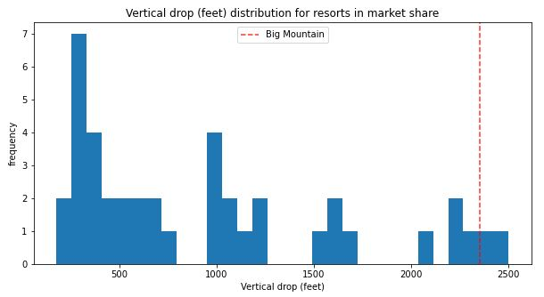

Big Mountain currently charges $81 per adult ticket. Based on the pricing models, the tickets could be valued at approximately $85. They are at the top of their market share for skiiable area and longest run, and even above average for number of runs. Based on the fact that other resorts within the market share charge upwards of $85 while offering less, it is recommended that Big Mountain proceed with upping the ticket price to $85.